**Finance Club Open Project**

**Mean Reverse + Evening Star & Morning Star**

Mean Reverse is a mean based strategy while evening and morning star help in detecting the peaks.

For this strategy, I choose the Simple moving average of last 30 days and set the upper and lower band of it by adding and subtracting standard deviation from it.

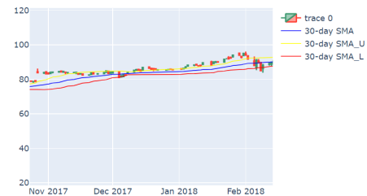The idea is simple, if the morning star pattern is detected below the lower band of the SMA we buy. If the evening star pattern is detected below the upper band we sell.

For the purpose of this strategy, I have chosen 10 year simple moving average and their upper and lower bond.

**Implementation**

First, we import all required libraries and import stock data from yfinance at a 1 day interval for the last 10 year. The graph for close price at a 1 day can be plotted which looks like this:

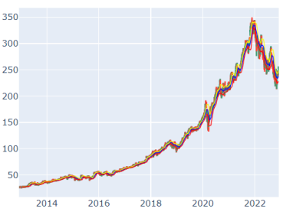

Capital is set at 1 lakh. Entry and exit conditions are set as defined in strategy. All trade data is then stored into a csv file.

Portfolio value is plotted against date. For the period of 2013-12-07to 2023-12-05(approx 8 years), the plot looks as follows:

**Portfolio returns**:

At 8 year timeframe, the return statistics are as follows:

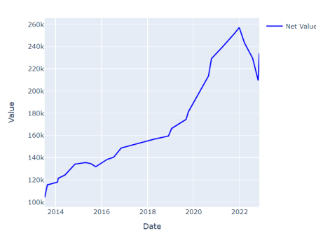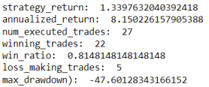

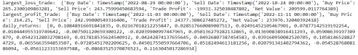Further developing the strategy: Instead of just taking help of morning star and evening star pattern we can also recognize doji pattern, spinning top pattern etc to detect the peaks.

For a timespan from 2012 to the start of 2022 the returns seems impressive

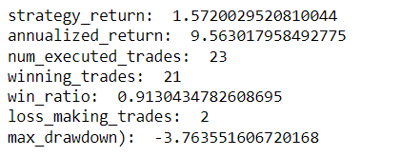

**Summary:**

The strategy works very well incase of all scenarios, but it is dominant in case of heavy fluctuations . This strategy tries to lessen the loss trades , in the above set of data only 5 loss trades proves it too.

This was my first stock market strategy project. I have learnt a lot and am looking forward to improve this to get even more return